
ACTIVITY REPORT
On
ACM Nexus
- Name of the Department : BMSCE ACM STUDENT CHAPTER
- Name of the Activity: ACM Nexus
- Objectives - The ACM Nexus aimed to introduce new members to the club's activities. The new members were informed about the ACM India Chapter Summit 2024, recent events, upcoming events of the club and their roles in the club. Members were also given suggestions on how to manage academics along with club work.
- Date, Time, Venue of the Activity – The event took place on 22nd of November, 2024 running from 4 PM to 6 PM in Audi 2 in the PJA Block.
Topic | ACM Nexus
Date/Day | Friday, 22nd November 2024
Venue | Audi 2

- Summary of the Program - On 22nd November 2024, the BMSCE ACM Student Chapter presented ACM Nexus, a lively and engaging meet for members hosted by Adwi. The event began with a warm welcome by Srikanth, followed by Roshini's talk about the club's recent and upcoming events. Kanishka then shared insights into the various roles within the club, such as marketing, design, logistics, and sponsorship, providing everyone with a clear understanding of the behind-the-scenes operations.
After a quick game to lighten the atmosphere, Bhuvan took the stage to discuss the ACM India Chapter Summit 2024. He covered important details like logistics, food, transportation, accommodation and the tentative schedule while showcasing the summit website. Speakers and guests for the ACM India Chapter Summit 2024 were also introduced.
This talk was followed by a games session hosted by Indraneel and Devaj, which encouraged interaction and lightened the atmosphere. The event wrapped up with a thank-you note by Hrithik and a group photo to commemorate the day.
- Outcomes - ACM Nexus was a great opportunity for members to connect and learn more about the club. It gave everyone a better idea of the different roles in the club and what’s coming up in the future. The talk about the ACM India Chapter Summit 2024 helped clarify the planning and logistics, while the games kept things fun and interactive. Overall, the event left everyone feeling more involved and updated.
Number of Faculty | Number of  Non-Teaching Staff | Number of Students
0 | 0 | 30

Number of faculty 0 | Number of  Number of external  Number of  non-teaching staff  participants  students  0 40 54
- Photographs of the event

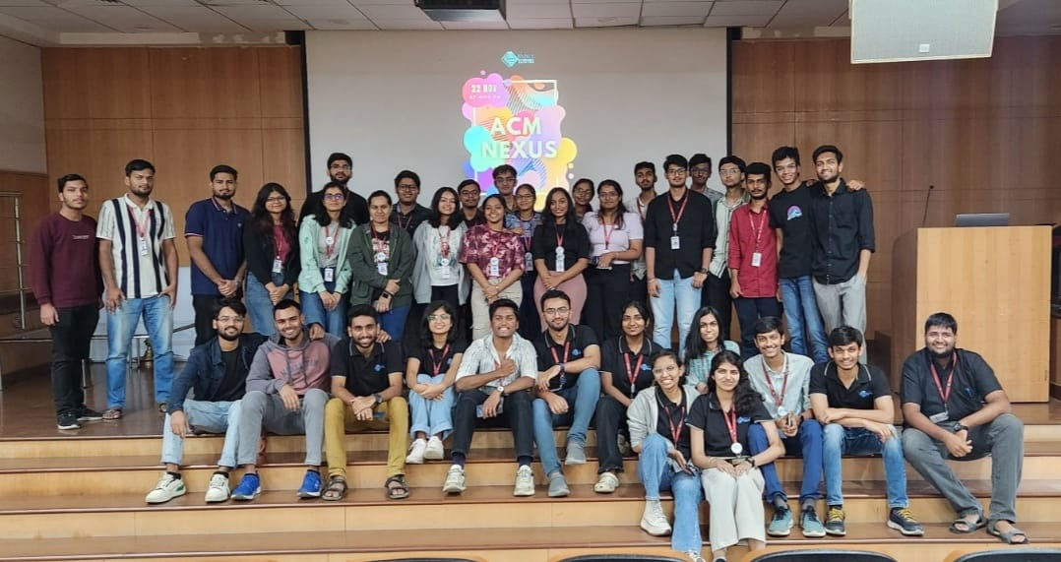

Supporting Documents
a. Circulars/Brochures

